**EXPLORE THE WORLD WITH**

**SHEAFE’S FLAT BLUEBIRD**

**Due Wednesday, December 21st**

STUDENT NAME: ___________________________________________ ROOM _____________

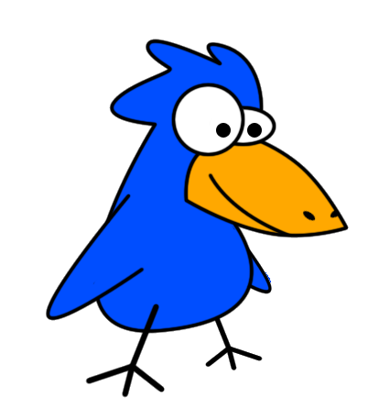

Hi Kids! Come fly with me as I travel around the world. We’re going to visit lots of great places while we learn lots of new things! This month we will be visiting:

**AUSTRALIA**

G’day Mate! We thank you for staying with us for a couple of weeks and wish you well on your trip. As you prepare to head South towards Antarctica, we wanted you to know that you might come across an animal that calls both Australia and Antarctica home, the PENGUIN! The penguins that are found in Australia are known as the “Little Blue Penguin” while the “Emperor Penguin” can be found in Antarctica. (There are also many more types of penguins that can be found in Antarctica).

Your task is to color in the penguin pictures using the directions and then label the penguin as a “Little Blue Penguin” or an “Emperor Penguin.”

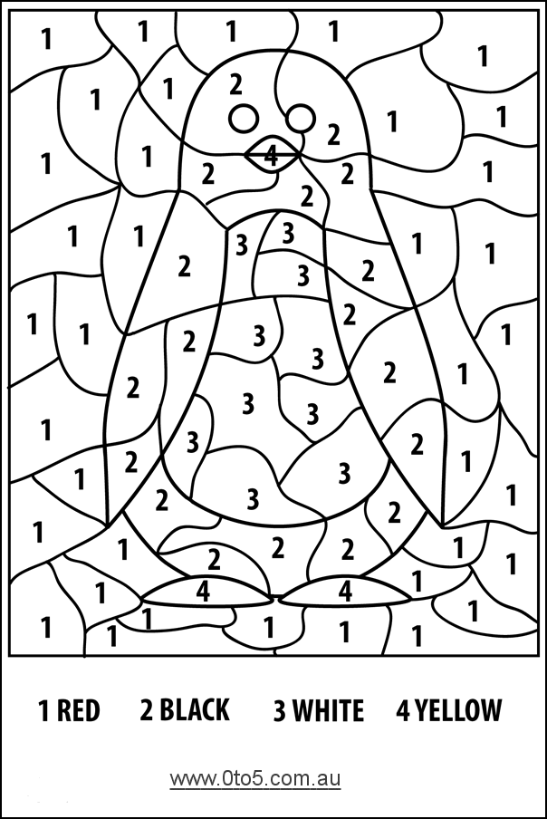

For more of a challenge, use the following pictures to create your own “color by number” penguin. You should make one picture a “Little Blue Penguin” and the second is a “Macaroni Penguin.” Good luck and have a safe trip!

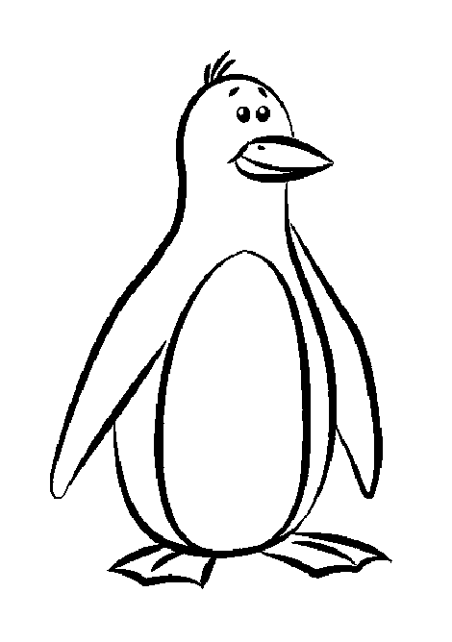

**Little Blue Penguin Coloring Key**

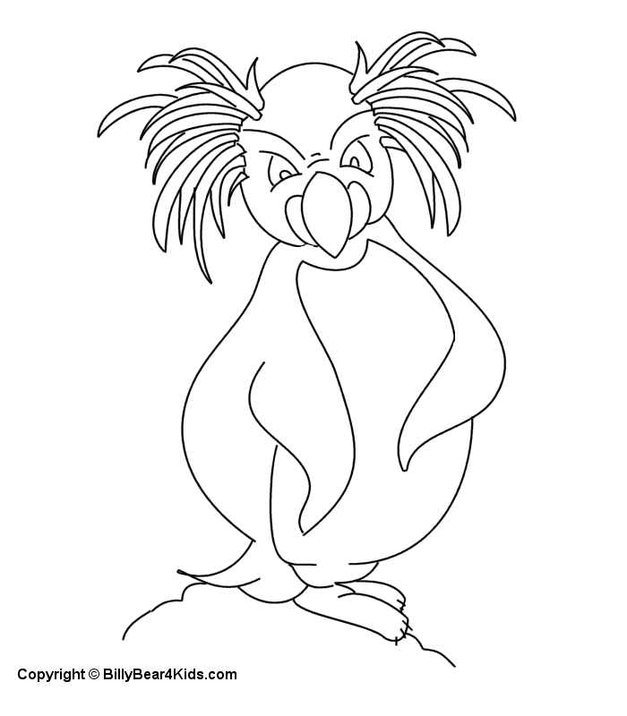

**Macaroni Penguin Coloring Key**